**UNIVERSITY OF BUEA**

**FACULTY OF ENGINEERING AND TECHNOLOGY**



**DEPARTMENT OF COMPUTER ENGINEERING (FET)**

**CEF 440: INTERNET PROGRAMMING (J2EE) AND MOBILE PROGRAMMING**

**TASK 5: UI DESIGN AND IMPLEMENTATION**

**NAMES OF GROUP MEMBERS**

|  |  |
| --- | --- |
| 1. AMBE MBONG-NWI NCHANG | FE20A007 |
| 1. ASONGNA FRANK TONGWA | FE20A012 |
| 1. BESINGI NAURA MABOLA | FE20A023 |
| 1. FONGE BERTIN AMIN-SHU | FE20A040 |
| 1. NKWETAKEM TABO BRUNO | FE20A091 |

**Course Instructor**

DR. VALERY NKEMENI

**Table of Content**

1. UI DESIGN ……………………………………………………………………………………………………………………………. 3
2. Introduction……………………………………………..…………………………………………………………….. 3
3. UI/UX Design Process…………………………………………………………………………………………….. 4-8
4. The Design………………………………………………………………………………………………………………8-14
5. IMPLEMENTATION

A. Technology Stack…………………………………………………………………………………………………….15-16

B. Development Process ………………………………………………………………………………………………16-17

C. User Interface Implementation……………………………………………………………………………….17-27

# **UI DESIGN**

# **INTRODUCTION**

This report aims to provide an overview of the design and implementation of the UI/UX. The purpose of this application is to facilitate a seamless interaction between buyers and sellers in a market setting, enabling buyers to access information about item availability, prices, and locations, while empowering sellers to showcase their products, prices, and market locations. This app serves the following key purposes for both buyers and sellers:

### **1. Buyers' Benefits:**

- Availability Information: Buyers can check the availability of their desired items before visiting the market, ensuring a more efficient shopping experience.

- Price Comparison: The application enables buyers to review prices of different items in the market, helping them make informed decisions and potentially find the best deals.

- Location Awareness: Buyers can view the market locations of various sellers, allowing them to plan their shopping route and optimize their time and effort.

### **2. Sellers' Benefits:**

- Product Display: Sellers can showcase their products in the application, providing an opportunity to attract potential customers and stand out in the market.

- Price Visibility: Sellers can list the prices of their items, ensuring transparency and enabling buyers to compare and evaluate their offerings.

- Market Location Exposure: Sellers' market locations are displayed, increasing their visibility and assisting buyers in locating their stalls or shops.

The UI/UX design and implementation of the mobile application have been carefully crafted to ensure a user-friendly and visually appealing experience for both buyers and sellers. The design focuses on providing intuitive navigation, clear presentation of information, and seamless interactions. The front-end implementation encompasses the conversion of the UI design into functional code, incorporating responsive design principles for compatibility across various mobile devices.

Throughout this report, we will delve into the specifics of the UI/UX design and implementation, highlighting key features, interface components, and the overall user journey within the application.

# **B. UI/UX DESIGN PROCESS**

## **A. User Research and Analysis**

To ensure that the mobile application meets the needs and preferences of the target users, thorough user research and analysis were conducted. The following methods were employed to understand the requirements and expectations of both buyers and sellers:

### **Interviews:** In-depth interviews were conducted with a select group of potential users, including both buyers and sellers. These interviews provided qualitative insights into their behaviors, motivations, and specific needs in the context of the marketplace.

The gathered data from user interviews was thoroughly analyzed and used to inform the UI/UX design decisions. The findings helped in identifying the key features and functionalities that would address the pain points of buyers and sellers effectively.

By conducting user research and analysis, the mobile application's UI/UX design and implementation were guided by a deep understanding of the target users' requirements and preferences. This approach ensures that the application is tailored to meet the needs of both buyers and sellers, facilitating efficient transactions and enhancing the overall user experience.

## **B. Methodology and Design Pattern**

In the design and implementation of the UI/UX, we made use of the Agile methodology, which adopts an iterative and incremental development approach. It breaks down the development into smaller sprints or phases to allow for continuous improvement and responsiveness to user needs.

Moving on to the design pattern, we made use of the Z design pattern, which is a common approach in mobile app design that follows the natural reading and scanning patterns of users. It helps guide users' attention and optimize the presentation of important information.

Here's how we applied the Z design pattern in the design of the UI/UX

### **a. Buyers' Perspective:**

1. Home Screen: Display the most essential and relevant information to buyers upon opening the app. This can include popular or trending items, featured sellers, or personalized recommendations.
2. Item Listings: Present the items for sale in a grid or list format, allowing buyers to quickly browse through the available items. Include key details such as title, price, availability, and location.
3. Item Detail Page: Provide a comprehensive view of each item, showcasing high-quality images, detailed descriptions, seller information, and pricing. Include a prominent call-to-action for buyers to express interest or make a purchase.
4. Location Mapping: Integrate a map feature to display the location of sellers in the market, allowing buyers to easily find and navigate to their desired sellers' locations.

### **b. Sellers' Perspective:**

1. Seller Dashboard: Offer sellers a personalized dashboard that provides an overview of their product listings, sales, and customer interactions. Include features to manage listings, update prices, and monitor performance.
2. Listing Management: Provide an intuitive interface for sellers to add, edit, or remove product listings. Include fields for title, description, pricing, availability, and location.
3. Seller Profile: Allow sellers to create and customize their profiles, including information about their business, contact details, and any special offers or promotions.

## 

## **C. Visual Design**

In the design of our UI/UX we incorporated a clean and modern aesthetic, with a focus on simplicity and clarity.

### **Color Scheme:**

We decided to make use of green which tellers the nature of how most of our local markets look on market days. Below is the color layout used in the design of our applications UI/UX:

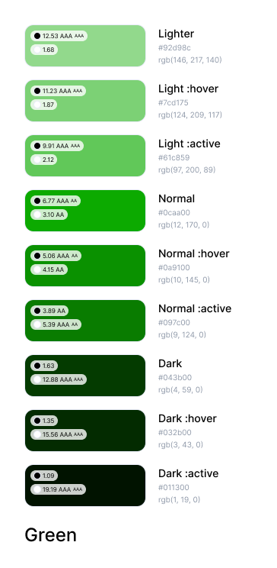

### **Typography:**

In the design and implementation of our applications UI/UX we decided to use montserrat and playfair light as our main fonts. These two fonts help us with legibility and visual hierarchy. They are also clear and easily readable fonts which are good for headings, titles, and body text, ensuring a comfortable reading experience for our users (buyers and sellers). Below is sample of our two fonts:

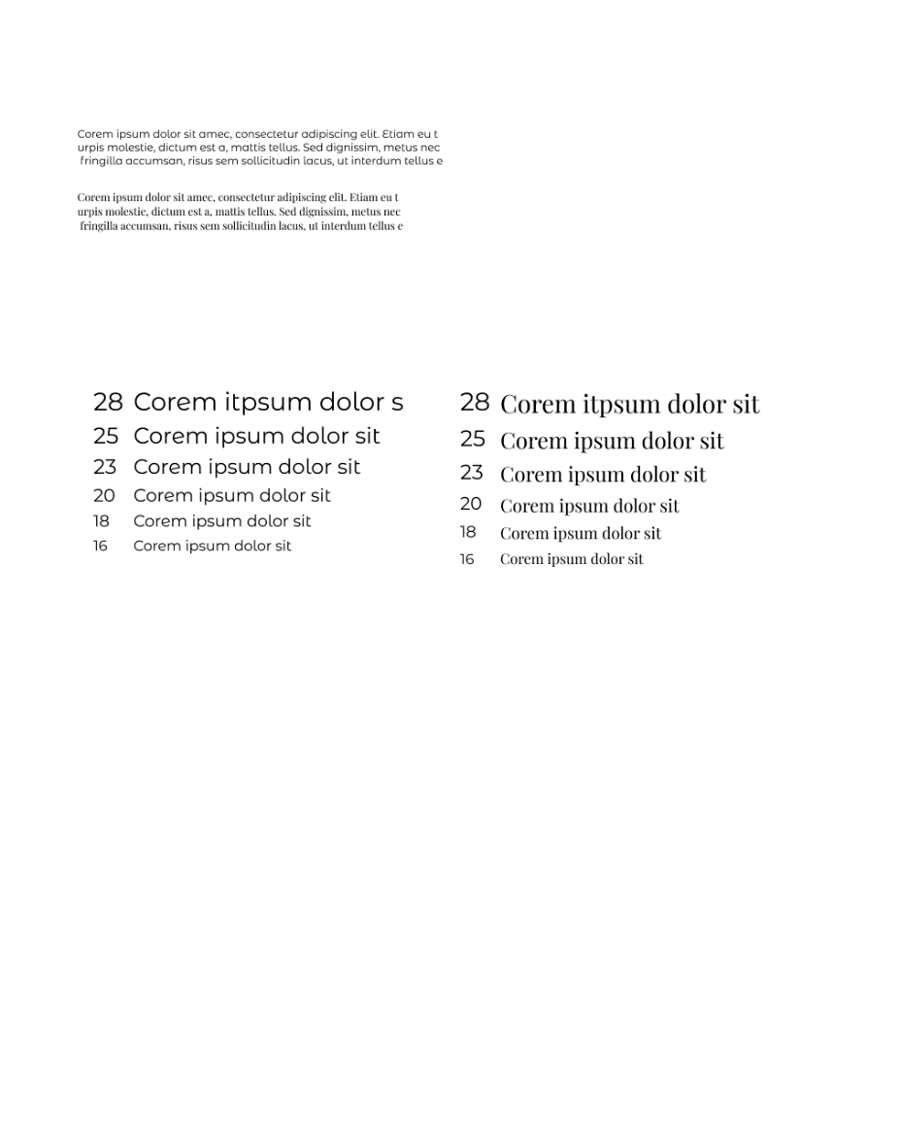

### **Buttons:**

We decided to use buttons with rounded edges because they provide an appealing view to the users when they are using our application. Below is how our buttons look like:

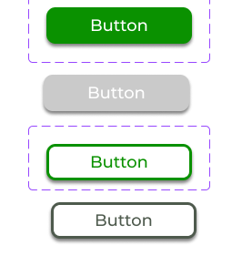

### **C THE DESIGN**

In designing the UI/UX we made use of one of the most popular design tools for designing UI/UX of applications which is figma. The reasons why we decided to use figma are listed below:

1. Collaborative Design: Figma allows multiple designers to work together in real-time, promoting collaboration and efficient decision-making among designers, developers, and stakeholders.
2. Cross-Platform Compatibility: Figma works seamlessly across different operating systems and devices, enabling designers to work on their preferred platform while ensuring compatibility and consistency when sharing design files.
3. Interactive Prototyping: Designers can create interactive prototypes within Figma, defining app flow, interactions, and animations. This helps stakeholders visualize the user experience and provides a realistic preview of the final product.
4. Design Components and Libraries: Figma supports reusable design components and libraries, promoting consistency and efficiency. Designers can reuse elements across screens or projects, reducing redundant work and maintaining a cohesive design language.
5. Design System Management: Figma provides robust features for managing design systems. Designers can create and maintain a centralized system for design tokens, styles, and guidelines, ensuring consistency in design elements throughout the app.
6. Developer Handoff: Figma simplifies the handoff process between designers and developers by generating design specs, exporting assets, and providing accurate measurements. This facilitates understanding of design requirements and accelerates the development process.
7. Plugins and Integrations: Figma supports a wide range of plugins and integrations, extending its functionality. Plugins automate tasks, provide additional design resources, and integrate with other tools and services to streamline the design workflow.

Below are the UI/UX designs for our application:

1. **Sign up pages**

The sign up screens allow a new user(buyer and seller) create an account with the Carryam-GO app. They are required to fill a form which contains vital information about them. Once that is done, they’ll have the opportunity to browse through

1 2

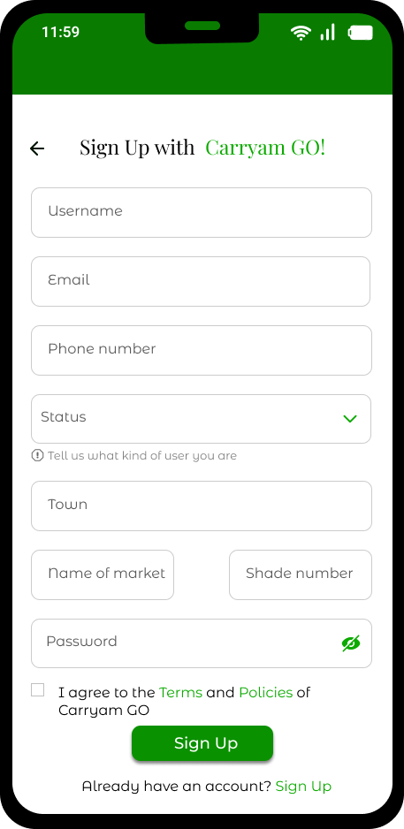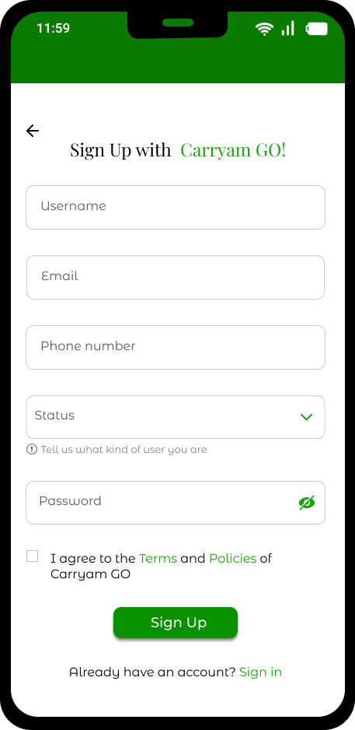

1. Screen 1 **the Buyer sign up** This screen allows the buyer create an account once they get into the app
2. Screen 2 **the Seller signup** which allows a buyer create an account on the app
3. **Forgot password screens**

These screens allow an already signed up user to change their password in case they have forgotten. The users have the ability to verify themselves either through email or their inputted phone number from the time of signing up. Once verification is done, they can create a new password

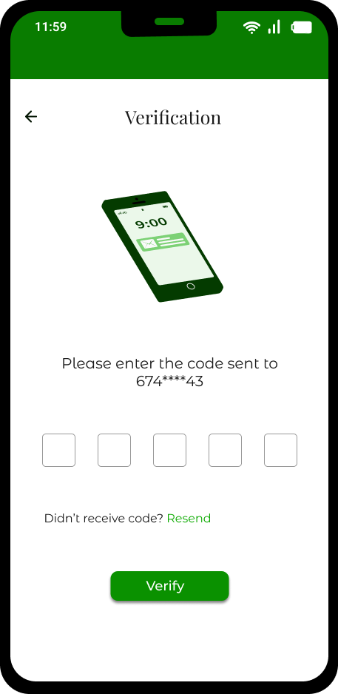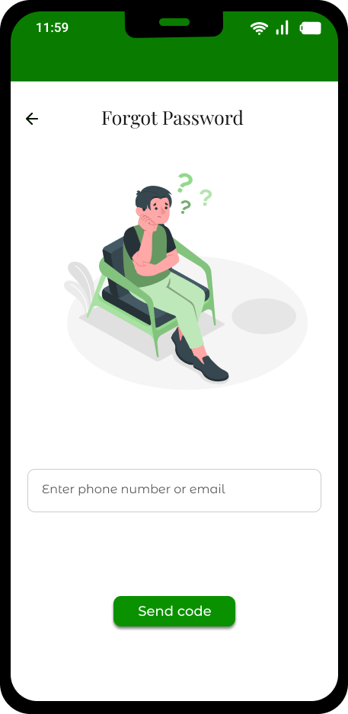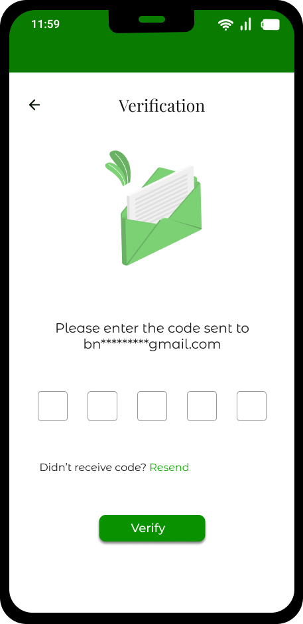

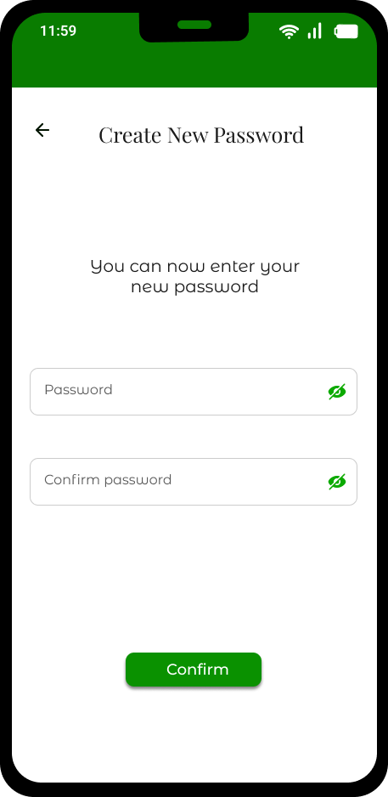

1. **Home screen, product catalog, Order and cart screens**

**1 2 3**

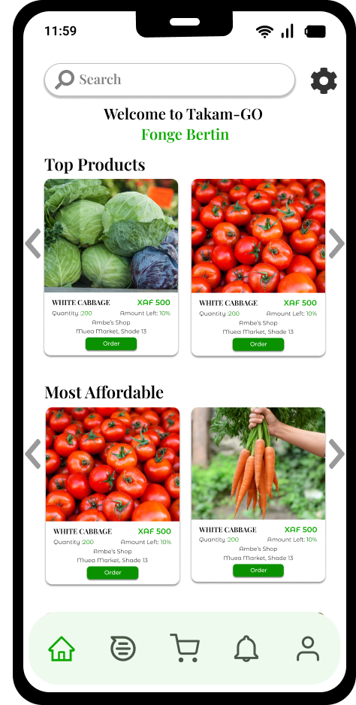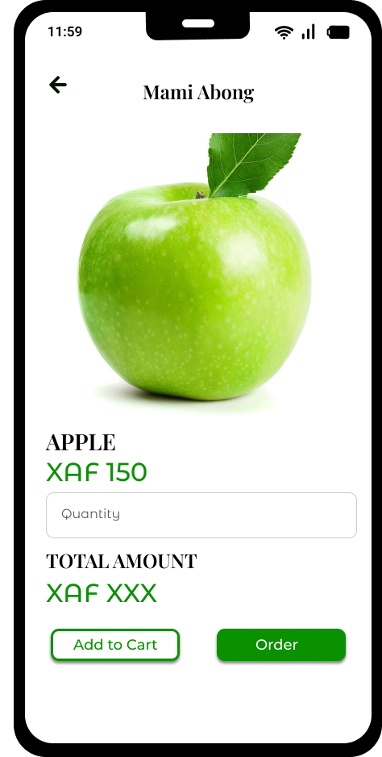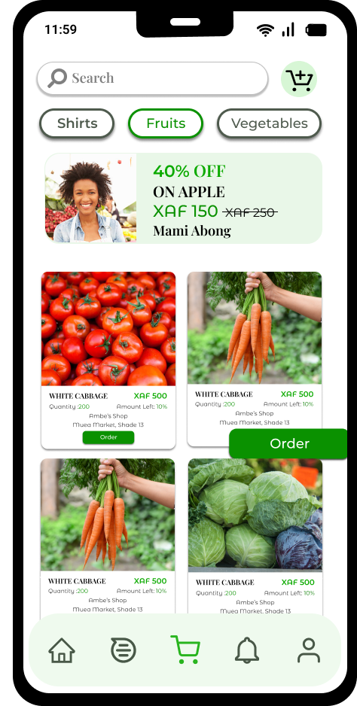

**4**

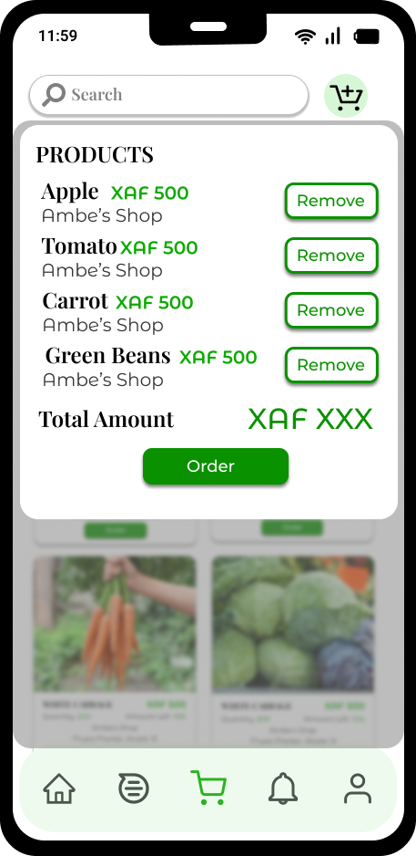

1. **Homescreen**

Once users are signed in, they have the ability to to see the various products available in the market which are divides into **Top products** available in the market and the **Most affordable** which show thecheapest goods in the market

1. **Product catalog screens**

This screen displays the different goods according to categories. That is by the type of product sold in the market. Users can also find available discounts or goods on promotion and they can place an order

1. **Order screen**

This screen allows a buyer place an order by choosing a particular product they want and inputing the quantity of the product they want

1. **Cart screen**

It shows the different products that have been ordered by the buyer, giving them the option of removing a product from the cart in case they no longer want that particular product and displaying the total cost

1. **User Profiles**

1 2 3

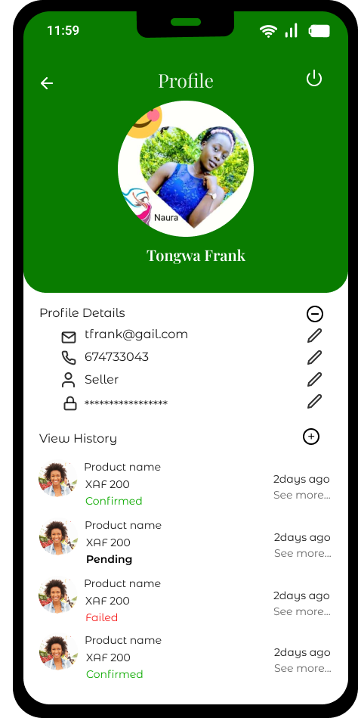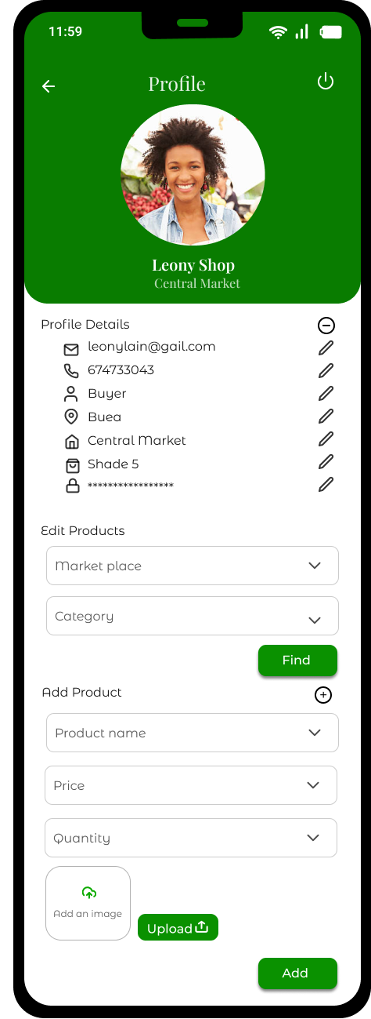

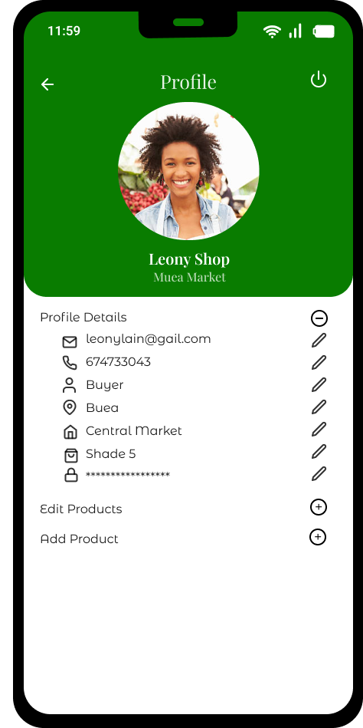

1. **Seller profile screens**

Screen 1 and 2 show the seller’s profile which shows their details inputted at the time of signup. It also allows a seller add a new product they sell and also edit some information about an already uploaded product such as the quantity. They can as well logout from their accounts

1. **Buyer Profile**

This screen shows the buyer’s personal details as well as the history of their various orders made. It also allows them log out from their account

1. **Messaging and Notification screens**

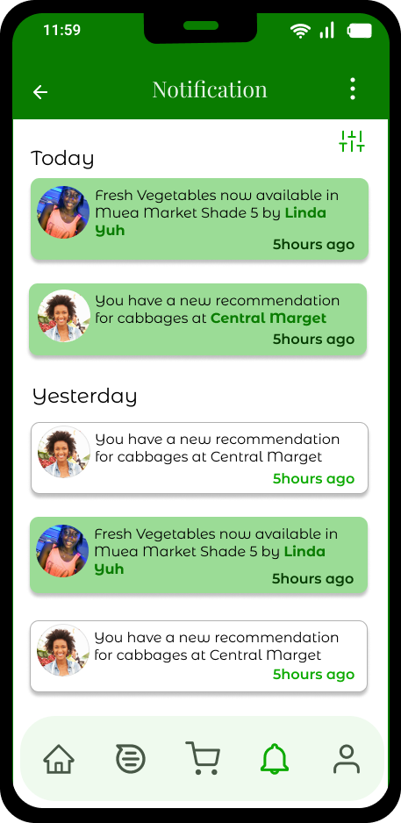 **1 2 3**

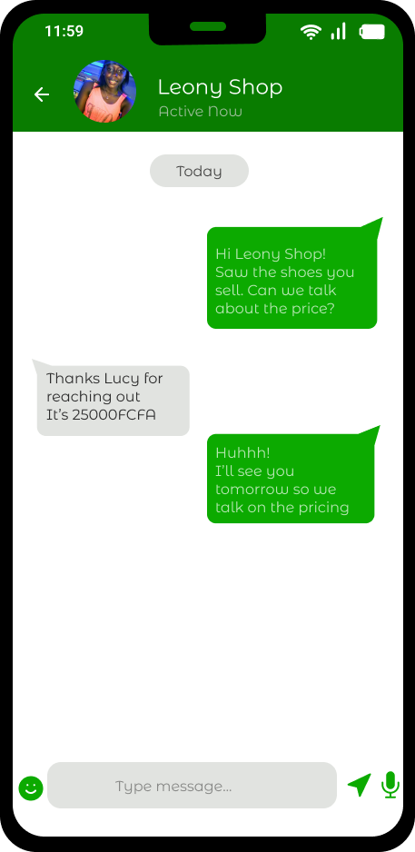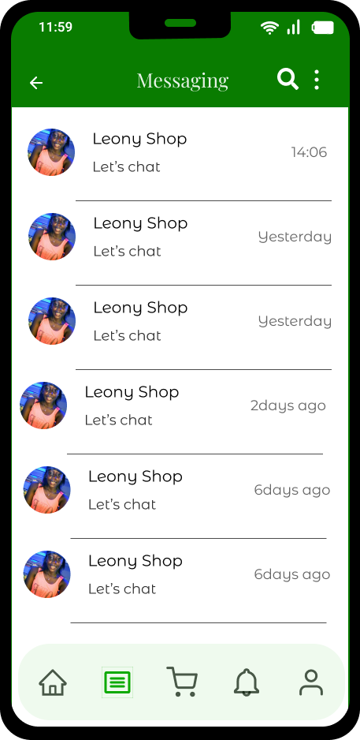

1. **Messaging screens**

These screens allow the the buyers and sellers communicate. They can decide to discuss pricing on whatever good and arrive to a comprise by chatting on the chatbox

1. **Notification**

Once orders have been placed, the sellers get notified here. The buyers also get notified of new trends in the market. Thus this screen allows buyers and sellers get notified from this screen

# **II. FRONTEND IMPLEMENTATION**

## **A. TECHNOLOGY STACK**

The UX/UX of the project was implemented using ReactNative.

### **What is ReactNative?**

ReactNative is an open source mobile application development framework created by Facebook.

It uses Javascript to create cross-platform mobile applications enabling us to develop mobile apps for both iOS and Android simultaneously using a single codebase.

### **Why Use ReactNative?**

ReactNative was chosen due to the following reasons:

1. Mobile App Development: We are developing a mobile application to enable a majority of our target population (buyers and sellers) to easily access the application.

2. Code Reusability: It creates cross platform apps hence helping us target a large population while saving time, effort and money.

3. Components: ReactNative allows us to create different components which can be reused wherever needed making it easier to create both simple and complex designs.

4. Third-Party Plugins: Many third-party plugins like Scroolbar, TouchableOpacity are provided that enhance the app’s functionality and performance.

5. Large Community Support: It has over 50,000 active contributors who have given answers to many problems that may arise in development.

6. Time and Cost Efficiency: A single team focuses on building a single codebase and no work duplication in building one system for Android and another for iOS.

7. Short Learning Curve: The learning curve was easier due to prior knowledge of the base language used here which is Javascript.

8. Live Reload: This allows us to see changes on our sample device when we reload the code.

## **B. DEVELOPMENT PROCESS**

Our development process followed an Agile methodology, specifically Scrum. The Scrum framework allowed us to iterate and deliver incremental updates to the mobile application, ensuring continuous improvement and flexibility throughout the development lifecycle.

### **1. Planning and Sprint Setup:**

- Conducted a planning session to define project goals, scope, and user stories based on the UI/UX design.

- Created a product backlog with prioritized features and functionalities.

- Split the development process into sprints, each with a specific duration (e.g., two weeks).

### **2. Sprint Workflow:**

- At the beginning of each sprint, hold a sprint planning meeting to discuss and select user stories to be implemented during that sprint.

- Collaborated with team members, including UI/UX designers, developers, and stakeholders, to ensure a shared understanding of the goals and implementation details.

- During the sprint, held daily stand-up meetings to discuss progress, address any challenges, and ensure alignment among team members.

- Implemented the frontend of the mobile application based on the UI/UX design, following coding best practices and guidelines.

- Conducted regular code reviews to maintain code quality and adherence to established standards.

### **3. Continuous Integration and Testing:**

- Utilized continuous integration tools to integrate code changes from different team members seamlessly.

- Automated unit testing and integration testing to identify and fix any functional or UI-related issues early in the development process.

- Conducted manual testing on various devices to ensure cross-platform compatibility and a smooth user experience.

### **4. Collaboration and Communication:**

- Fostered regular communication and collaboration among team members, including designers, developers, and stakeholders, through meetings, chat platforms, and project management tools.

- Maintained close coordination with the UI/UX designers to address any design-related questions or refinements during implementation.

By following this development process, we were able to efficiently implement the frontend of the mobile application, aligning it with the UI/UX design. The Agile and Scrum approach facilitated iterative development, regular feedback, and effective collaboration, resulting in a high-quality and user-centric application.

## **C. USER INTERFACE IMPLEMENTATION**

### **Running the Project:**

The expo-cli (command line interface) is a set of tools built around ReactNative. It was used as it abstracts away from the native code and makes it simpler to start developing in react by providing us a simpler development environment as well as utility features.

To run project:

• Download project from github

• In terminal, run npm install to install the needed node modules

• Run npm start to start the project

• Download the expo app on your phone

• Scan the QR Code generated and preview the app on your phone.

Currently Developed Pages and Reusable Components

### **Reusable Components**

**1. Footer:** This footer was created independently so it can be reused. It contains icons which when tapped on help us navigate to the various pages of the app. The icons are;

• home icon: For homepage

• message icon: For Messaging page

• Cart icon: For cart page

• the bell icon: For notification page

• the person icon: For profile page.

The footer has also been placed at a fixed position at the bottom of the page.

**2. Card:** This component was created to display various products available in the market. The cards contain the following:

• Picture of available food

• Food name, price

• Amount of that item available

• Shop name

• Market name

• Shade number

• The order button.

### **Developed Pages**

**1. Sign Up Page:** This page helps the buyer and seller sign in when they first visit the app.

▪ The information needed for signup which are username, email, phone number and password are prompted using the TextInput component.

▪ A Switch component is used to prompt the user to agree to the Terms and Policies of CarryamGo.

▪ Lastly the touchableOpacity component is used to develop the Sign Up button

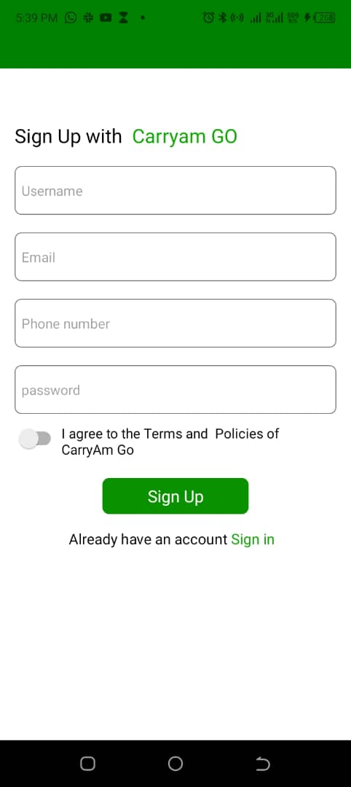

## 

**2. Home Page:** This is the first page the user sees after successfully signing up.

This page is made of;

• Search Bar: Implemented using TextInput component which aids the user search for any food she wishes to purchase.

• Next to the search bar we have the settings icon which enables users to change app settings.

• Welcome Message: This message welcomes the user to the application implemented using the Text component

• Cards displaying the food items

• Footer for navigation

• The ScrollView component was used to enable scrolling due to the many available food items which exceed the present screen sight.

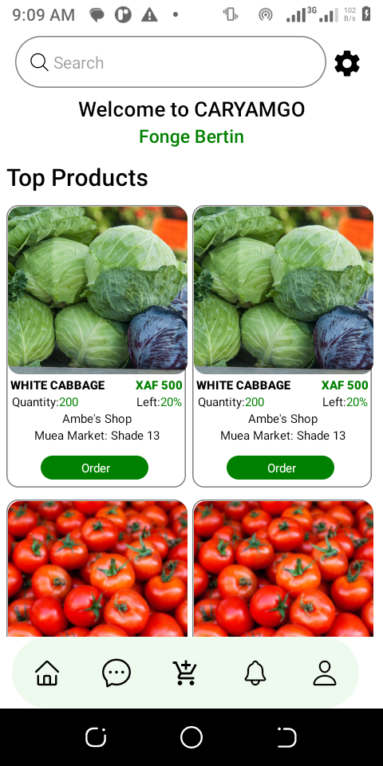

**3. Discount Page:** This page has helped buyers search for all foodstuffs which presently have a discount. It is made up of;

• search bar which enables buyers to search for food items which presently have a discount on the market.

• The cart icon here enables users to either confirm the total number of ordered goods or delete the goods which are not needed.

• Cards displaying the food items

• Footer for navigation

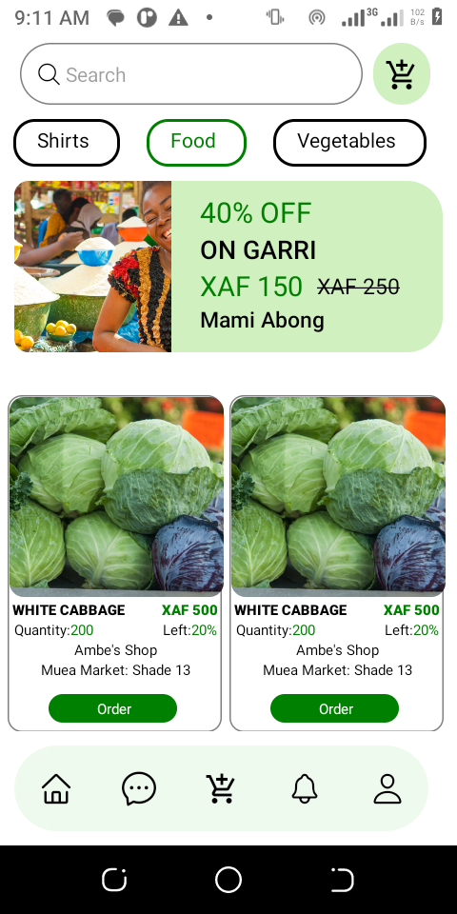

**4. Notification Page:** This page shows all the various notifications given to the user in recent times.

• We have the arrow in the header which enables us return to the Home Page (Stack Navigation)

• We have the various notifications ant the time they were delivered

• Lastly, we have the footer.

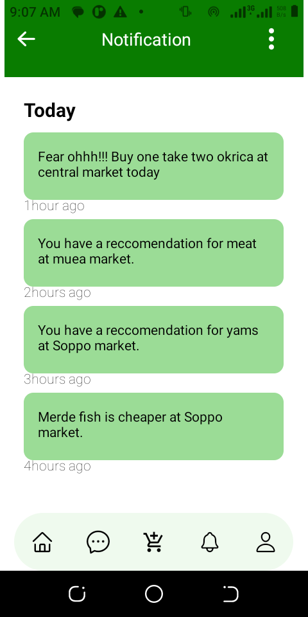

## **D. Components Used**

React Native Components Used so Far

• TouchableOpacity: Used instead of button so it can be styled.

• View: Container view acts like a div

• Text: To display text to users

• TextInput: Enables users type in input using the default keyboard it provides

• Switch: Enables users accept or decline our policies at sign up page

• ScrollView: Used to enable scrolling on a page

• Stylesheet: Enables styling of components.

# **IV. Testing and Quality Assurance**

During the implementation of the UI/UX design of the mobile application, various testing strategies and methodologies were employed to ensure the quality and usability of the UI/UX design and implementation. The following aspects were considered in the testing process:

### **1. Testing Strategies:**

- Functional Testing: Verifying that all frontend features and functionalities work as intended, such as displaying product information, prices, and locations correctly.

- Usability Testing: Evaluating the user-friendliness and intuitiveness of the UI design by conducting user tests and gathering feedback.

- Compatibility Testing: Checking the application's performance and appearance across different devices, operating systems, and screen sizes to ensure a consistent experience.

- Performance Testing: Assessing the speed and responsiveness of the UI, ensuring smooth navigation and efficient data retrieval.

- Security Testing: Identifying and addressing any potential vulnerabilities or risks related to user data and transactions.

### **2. UI/UX Testing:**

- Responsiveness Testing: Verifying that the UI adapts and displays correctly on various devices, including smartphones and tablets, with different screen sizes and orientations.

- Usability Testing: Observing and collecting feedback from users to evaluate the ease of use, intuitiveness, and overall satisfaction with the UI/UX design.

- Visual Design Testing: Assessing the visual elements, including colors, typography, and graphics, to ensure they align with the intended design and branding guidelines.

By conducting thorough testing and quality assurance processes, the mobile application's frontend was verified to meet the UI/UX design and implementation requirements. This helps ensure a seamless and satisfying experience for both buyers and sellers, allowing them to effectively utilize the app's features to access item availability, prices, and locations in the market.

# **V. Conclusion**

Enhanced User Experience: The UI/UX design focuses on providing a seamless and intuitive experience for both buyers and sellers. The design elements, layout, and interaction components are optimized to ensure easy navigation, clear information display, and efficient interactions.

Improved Decision Making for Buyers: By providing access to information such as availability, prices, and location of desired items in the market, buyers can make more informed decisions before visiting the physical market. This feature saves their time and effort by allowing them to plan their shopping trips accordingly.

Increased Visibility for Sellers: Sellers can leverage the application to showcase their products, prices, and location in the market. This visibility helps attract the right customers to their stalls or shades, increasing their chances of making sales. The app acts as a marketing platform for sellers to reach potential buyers efficiently.

Convenience and Efficiency: The application brings convenience to both buyers and sellers by streamlining the process of searching for items, comparing prices, and identifying locations. Buyers can quickly find the desired items and sellers, saving time and reducing frustration. Sellers can effectively manage and display their products, improving their selling efficiency.